Getting Started with MPLAB

1. Run MPLAB X
   1. The first time the program runs you will encounter a firewall prompt. Allow MPLAB.
2. This is the Start Page when MPLAB is started. It will be seldom if never used.

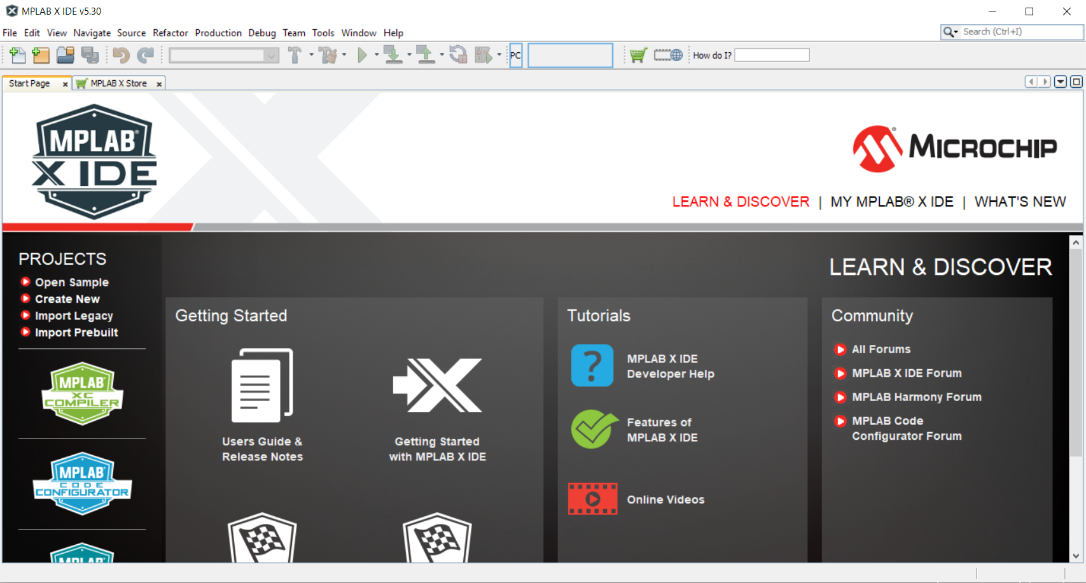

1. We must add the AVRASM complier to our list of toolchains.
   1. Go to Tools > Options > Embedded > Build Tools

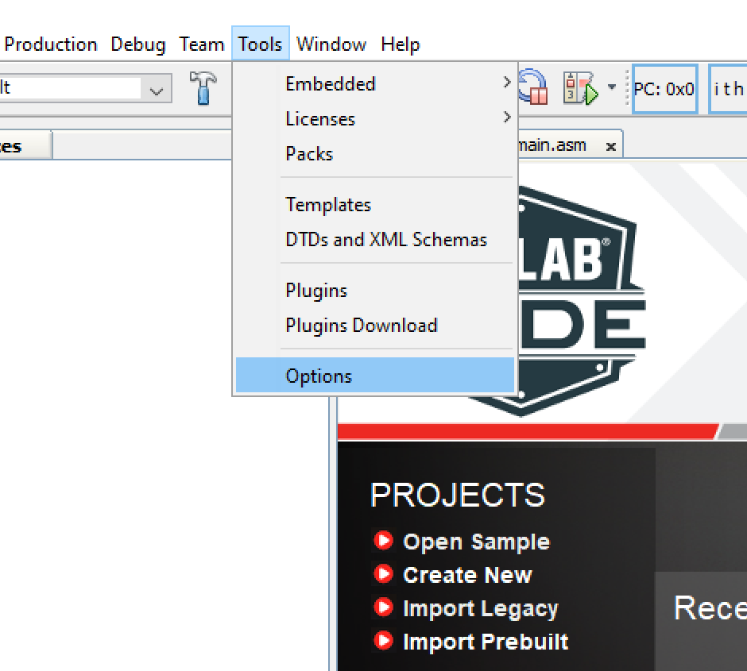 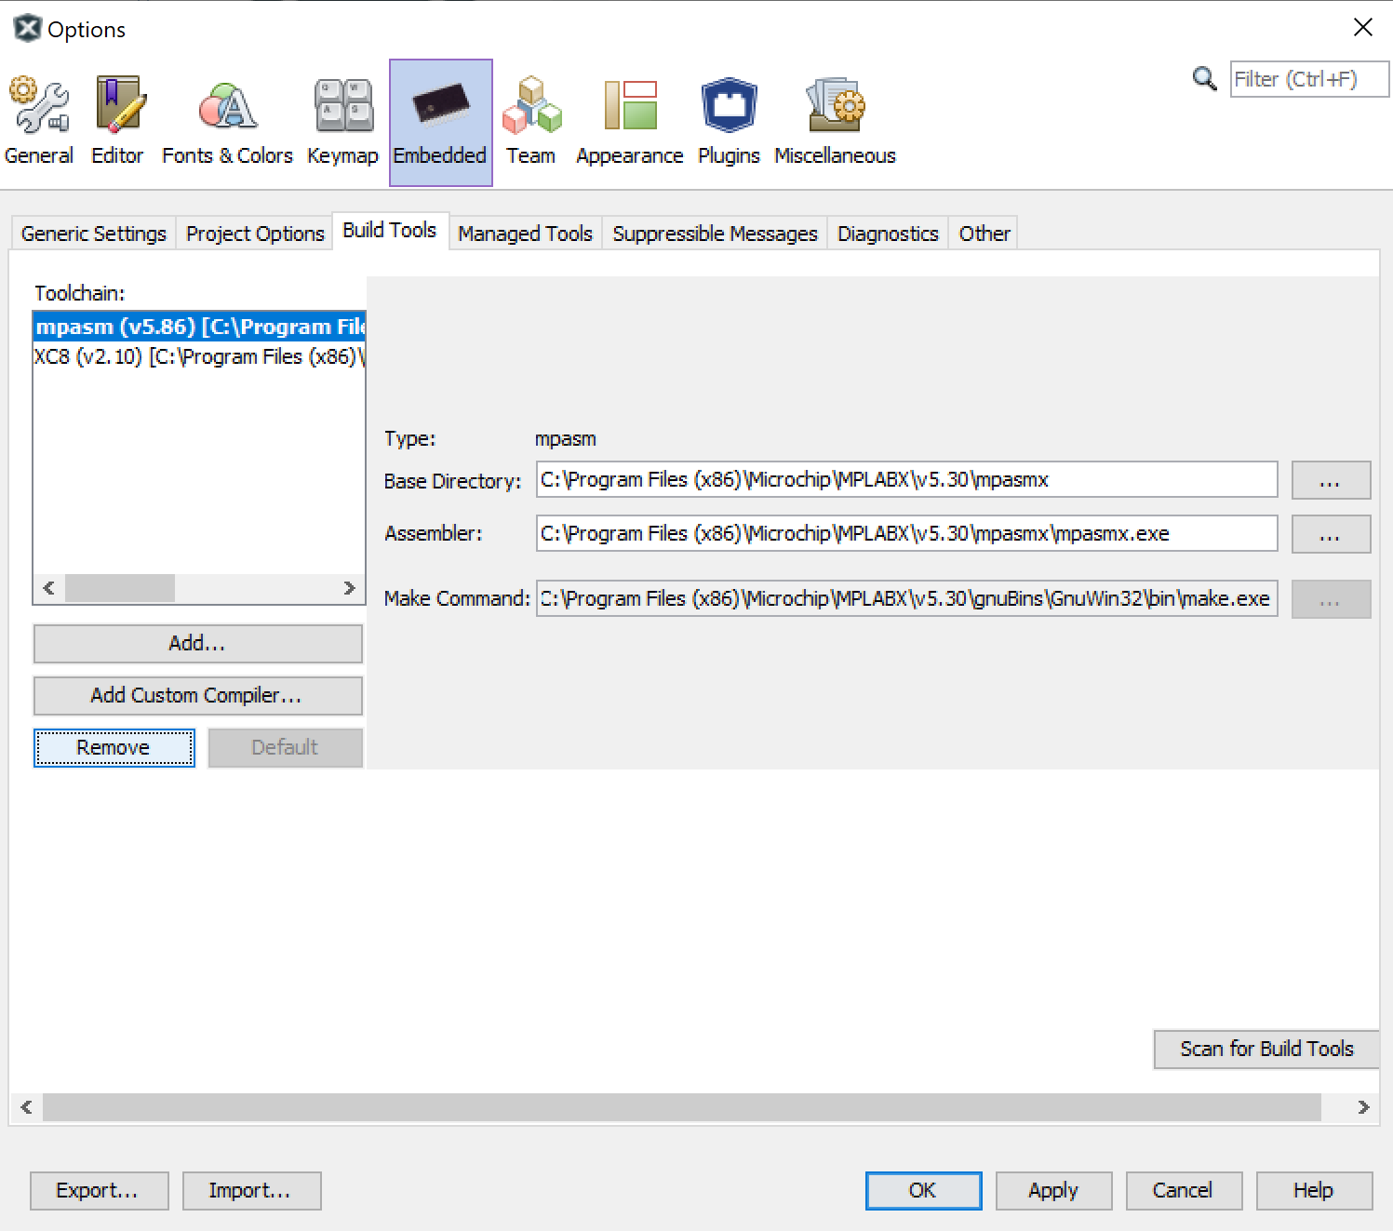

* 1. Click **Add…** Then click **Browse…**
  2. Navigate to your microchip install directory. Typically is: C:\Program Files (x86)\Microchip
  3. Go to C:\Program Files (x86)\Microchip\xc8\v2.10\avr\bin
  4. Click **Open…**
  5. Under Version, select avrasm2

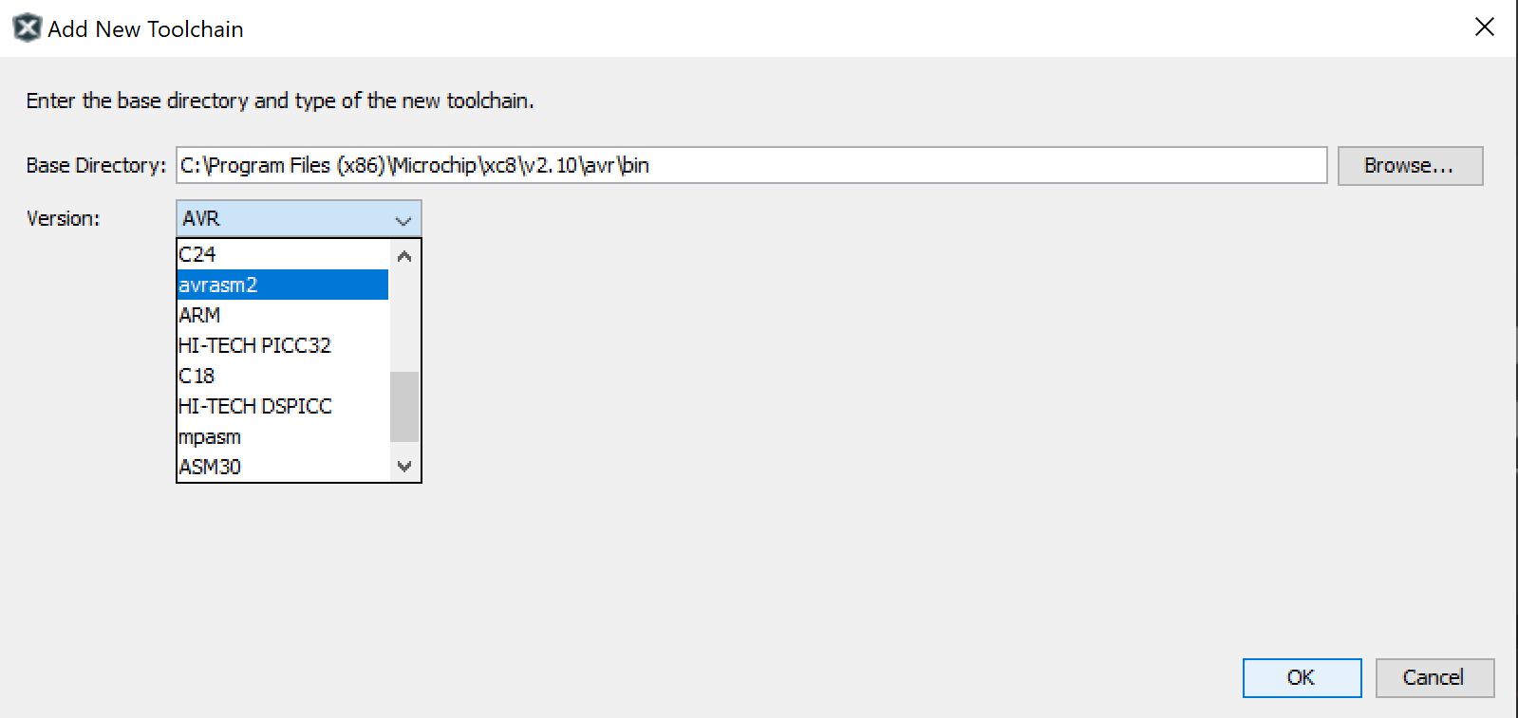

* 1. Click **OK**. You now have both the XC8 and AVRASM compilers available.

1. Create a new project by clicking the  icon in the upper-left corner.

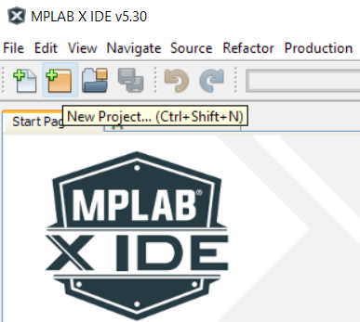

* 1. Select **Standalone Project** as seen below and click **Next**

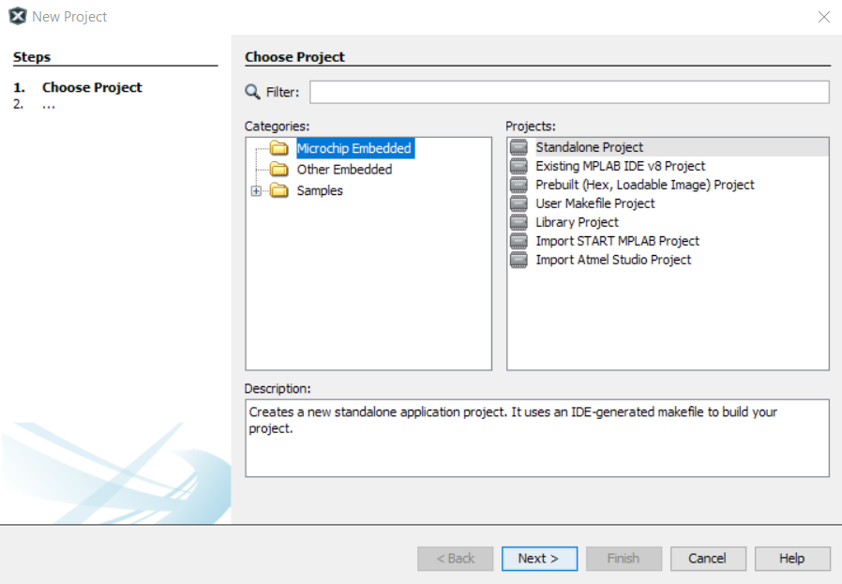

* 1. Next select **8-bit AVR MCUs** and the **ATmega324PB** from the devices list and click **Next**

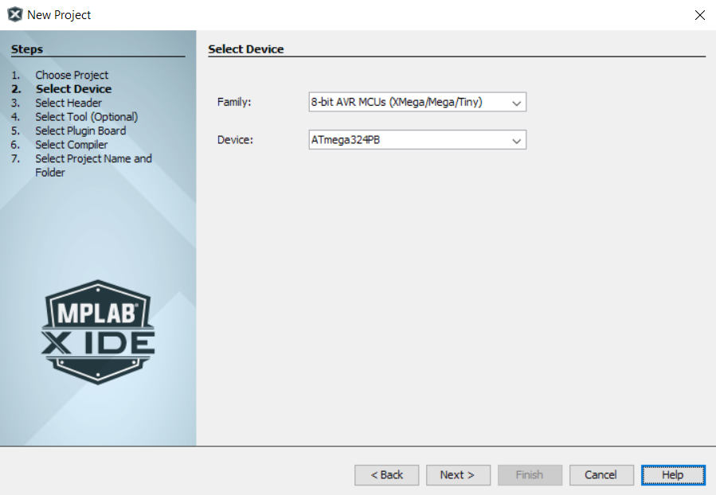

* 1. Skip select Tool, just click **Next**
  2. **Select Compiler** based on the language of your program:

For C choose **XC8**

For ASM choose **avrams2**

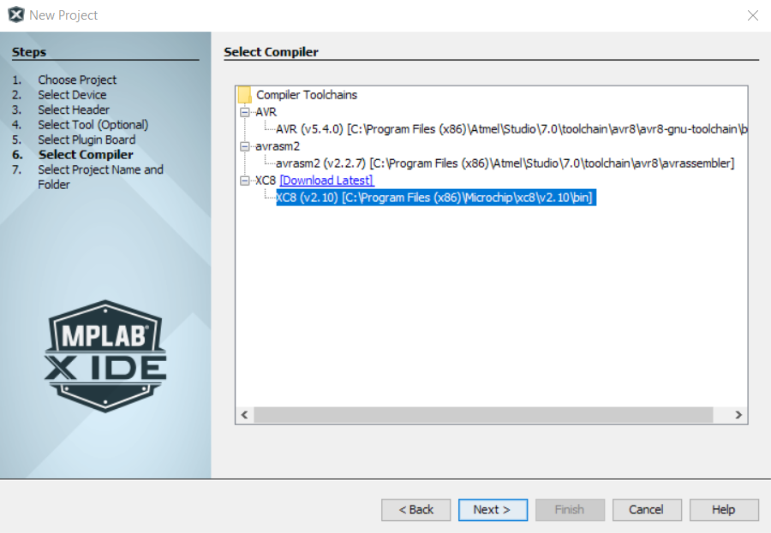

* 1. Finally, assign your project a name and a directory and click **Finish**.

**IMPORTANT NOTE:** Make sure the directory path does not contain spaces.

**Bad:** C:\Users\Admin\Documents\My Project

**Good:** C:\Users\Admin\Documents\My_Project

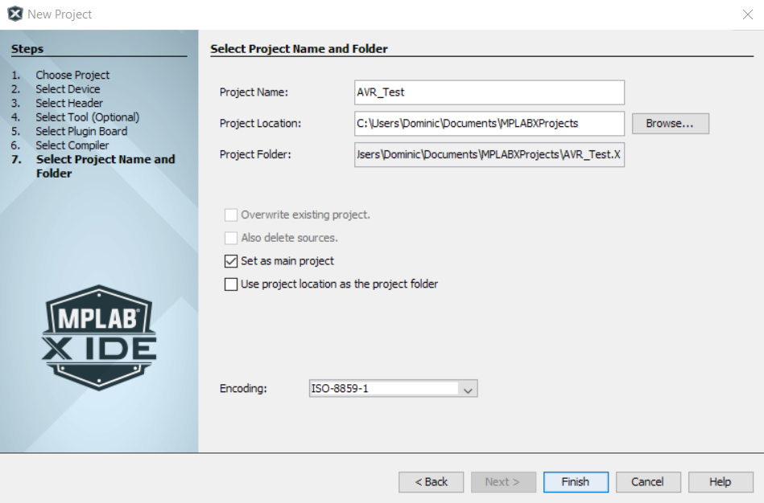

* 1. Your screen should now look like this:
     1. The upper-left portion contains the Project Tree, File Tree, Class Tree, and Services Tree. We will only focus on the Project Tree to create, add files and view project files.

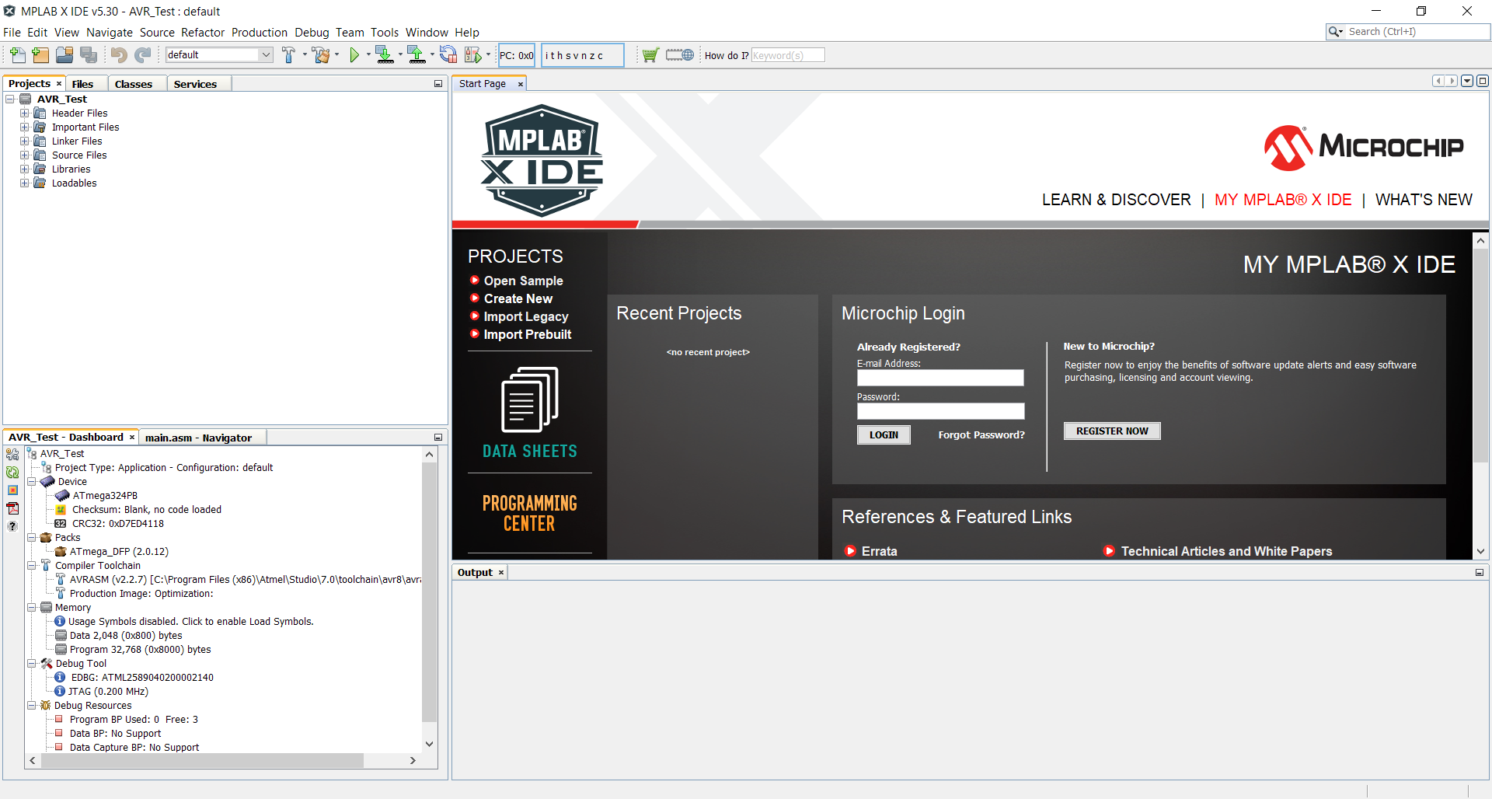

Creating and Adding Files to Your Project

1. Files can be added in many ways
   1. Clicking the  icon
   2. Right clicking any project folder and selecting **New…**
   3. Right clicking any project folder and selecting **Add Existing Item…**
      1. If you choose this be sure the original file is in a directory with no spaces in its path. A good rule is to just put the file in your project directory before adding it.
2. We’ll start by adding the **main.asm** file to our **Source Files** folder
   1. Download the main.asm file from Canvas to your project directory
      1. If you didn’t specify a directory, the default is:

C:\Users\”Username”\MPLABXProjets\MyProject.X

* 1. Right click **Source Files** and select **Add Existing Item…**

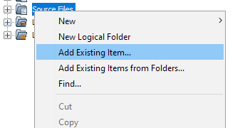

* 1. Select the **AMS Source Files** file type and then the **main.asm** file from your project directory.

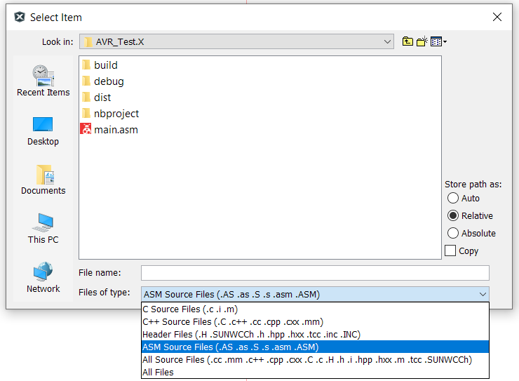

* 1. Once the file is loaded double click it in the project tree to open it. With the file in the project we now have to ability to compile/build it.

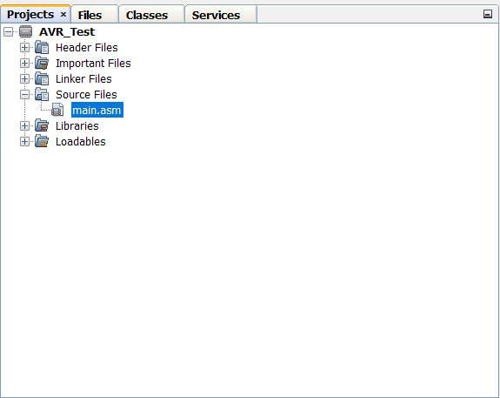

Build your Code

1. Building is very simple in MPLAB X. With the source file in the project simply click the  icon to clean and build or  to just build.
2. The output console should show dialog indicating a successful or failed build

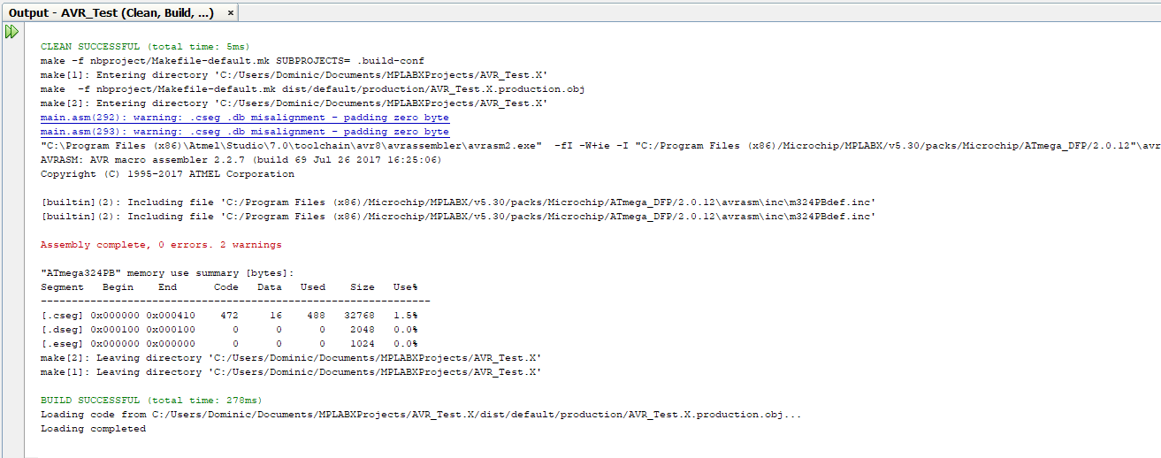

* 1. If your build fails, look in the output console for possible errors. Also be sure that if you are compiling ASM that you are using the AVRASM toolchain. The toolchain you are using is shown in the lower-left quadrant under **Compiler Toolchain**

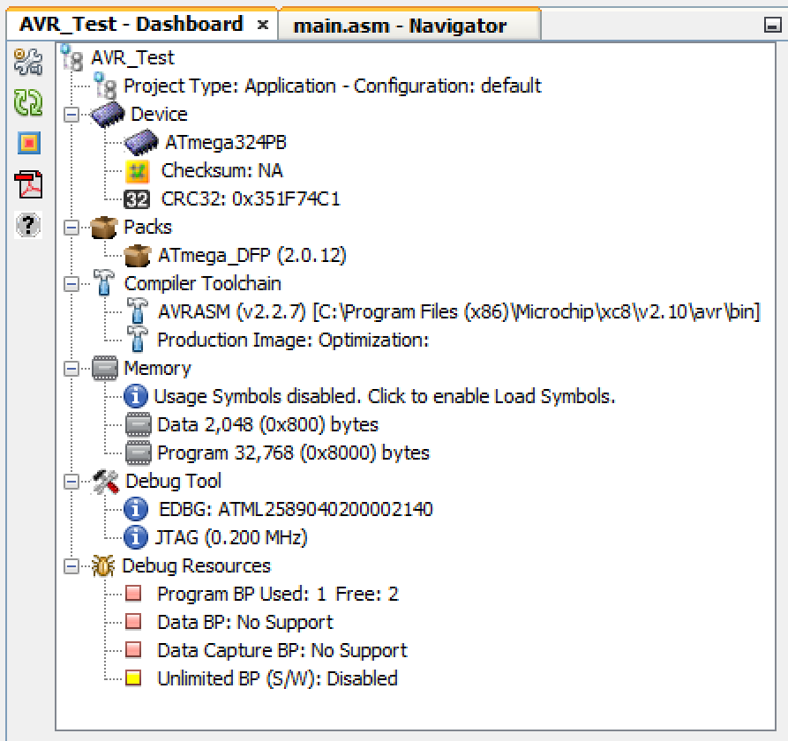

Programing your Device

1. Plug your device into your PC using the micro USB cable provided.
   1. You should see a tab popup with information about the board.

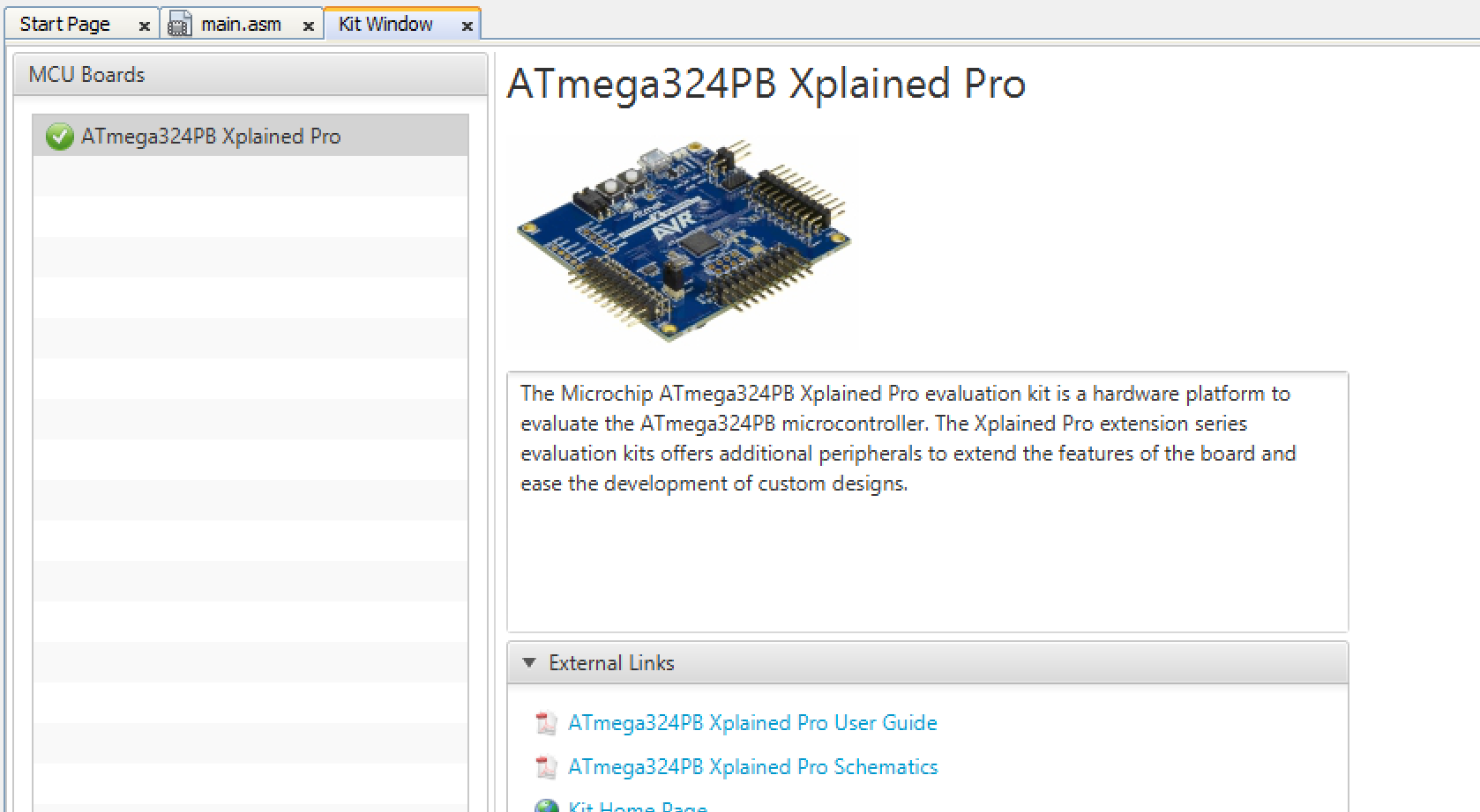

1. Click the dropdown arrow next to this icon  and select **Erase Device Main Project**
   1. You may be asked to select the device programmer. Select the **ATmega324PB Xplained Pro (EDBG)**

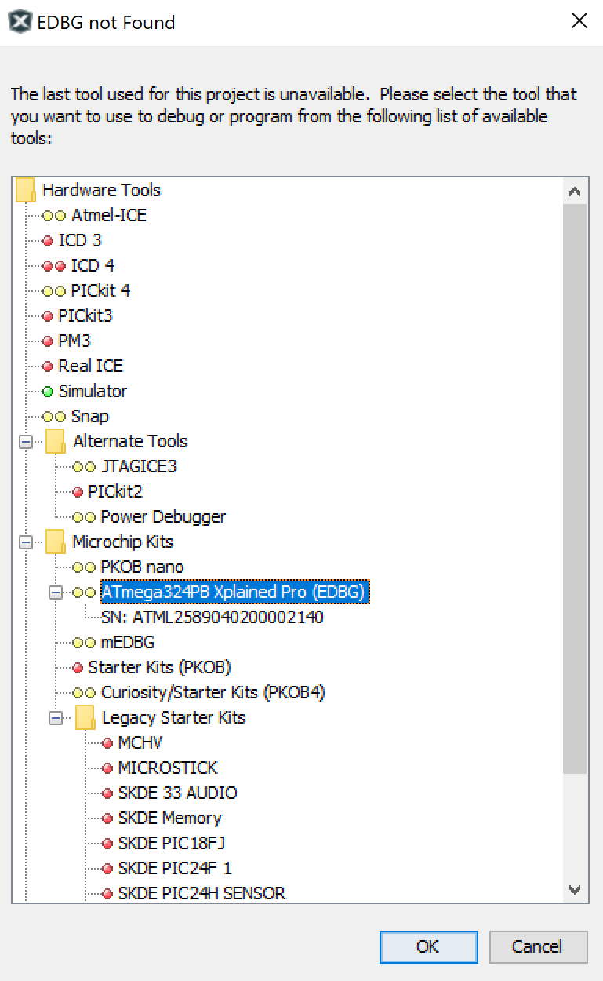

1. Confirm the device is no longer running the previous program by pressing the buttons on the board.
2. Now click the  icon to program your code onto the board.
3. Press the buttons on the board to confirm is has been programmed.